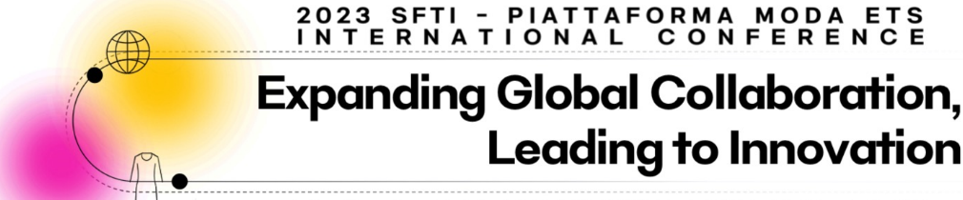 | CALL FOR ABSTRACTS

The Society of Fashion & Textile Industry (SFTI) and Piattaforma Sistema Formativo Moda ETS (Plattaforma) are jointly hosting an international conference in Milan, Italy. The conference includes special lectures, research presentations (both oral and poster) and pre & post industry visits. You are cordially invited to submit papers for the SFTI-Piattaforma international conference. Abstracts are encouraged from the full range of fashion and textiles disciplines in both academic and professional.

Co-hosts The Society of Fashion & Textile Industry (SFTI) http://www.clothing.or.kr/
Piattaforma Sistema Formativo Moda ETS (Piattaforma) https://piattaformamoda.it

Venue Aula, Magna, IED Milano, Italy

Dates July 6-8, 2023 (presentation date July 7)

Theme Expanding Global Collaboration, Leading to Innovation

Presentation Oral presentation or poster presentation
Types

Cover Page: Title of paper and name and contact information (affiliation, position, phone, email) for all authors. Indicate correspondence, presentation type and keywords.

Abstract: Written in English and submitted in a word document
Minimum 300 words

Types: Original abstracts
Teaching abstracts (teaching technique, curriculum development)
Cases/Concept abstracts (emerging issues, best practice, policies and others)

Topics: Aesthetic, Fashion design, Clothing construction, apparel production, Clothing hygiene/comfort, ergonomics, Consumer behavior, Fashion marketing, Retailing, Merchandising, History, Folk costume, Social psychology of clothing, Textile design, Textiles materials, textile care and management, Teaching technique, curriculum development, industry cooperation, and all other areas

Submit your cover page and abstract to:
Authors from Italy: to be determined
Authors from all other countries: sfti98@naver.com

Information/Inquiries
Kyu-Hye Lee, Hanyang University khlee@hanyang.ac.kr
to be determined, Italy

Submission deadline: June 15, 2023
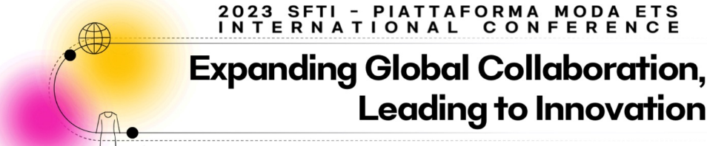 | Abstract for review  COVER PAGE

Abstract submission deadline: June 15, 2023

Poster/oral presentation file (PPT) deadline: June 30, 2023
*After successful presentations, authors will be encouraged to submit the full paper to Fashion & Textile Research Journal (KCI indexed) for an expedited review.

Author information (in the order of authorship)
Name | Affiliation  (include city & country) | Position  (job status) | Tel | Email

Presenter (name and email)(if different from the corresponding author):

Corresponding author (name and email):

Presentation type □ Oral presentation □ Poster presentation

Types: □ Research □ Teaching □ Cases/Concept

Keywords: (3 to 5 keywords)

Funding Source: (if it needs to be indicated)

-Include an abstract text (minimum 300 words) with the cover page-

